EXPERIMENT NO-11: MAP COLORING TO IMPLEMENT CSP
Aim
To implement the Map Colouring problem using a Constraint Satisfaction Problem (CSP) in Python, where adjacent regions must have different colours.
Algorithm
- Define the regions and their neighbouring regions.
- Define a set of available colours.
- Assign colours to regions using backtracking.
- Before assigning a colour, check whether it conflicts with any already-coloured neighbouring region.
- If there is no conflict, assign the colour and move to the next region.
- If no colour is possible, backtrack and change the previous assignment.
- Continue until all regions are coloured.
Python Program
# Map Colouring using Constraint Satisfaction Problem (CSP)

# Map of neighbouring regions
map_graph = {
'A': ['B', 'C'],
'B': ['A', 'C', 'D'],
'C': ['A', 'B', 'D'],
'D': ['B', 'C']
}

# Available colours
colors = ['Red', 'Green', 'Blue']

# Dictionary to store the colour assignment
assignment = {}

def is_safe(region, color):
for neighbour in map_graph[region]:
if neighbour in assignment and assignment[neighbour] == color:
return False
return True

def solve_csp(regions):
# All regions are coloured
if len(assignment) == len(regions):
return True

# Select the next uncoloured region
region = regions[len(assignment)]

# Try each colour
for color in colors:
if is_safe(region, color):
assignment[region] = color

if solve_csp(regions):
return True

# Backtrack
del assignment[region]

return False

# List of regions
regions = list(map_graph.keys())

# Solve the CSP
if solve_csp(regions):
print("Map Colouring Solution:")
for region in regions:
print(region, "->", assignment[region])
else:
print("No solution exists.")
OUTPUT
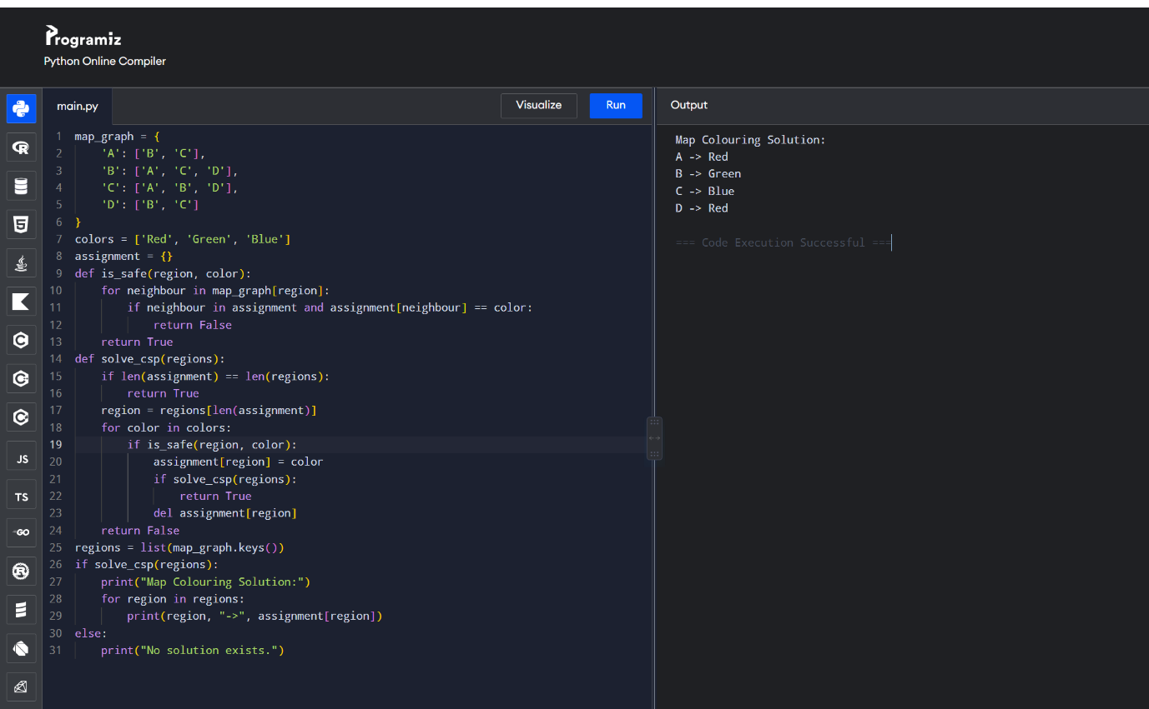
Result
Thus, the Map Colouring problem was successfully implemented using CSP and backtracking in Python, ensuring that no two adjacent regions have the same colour.

